WEEK 6

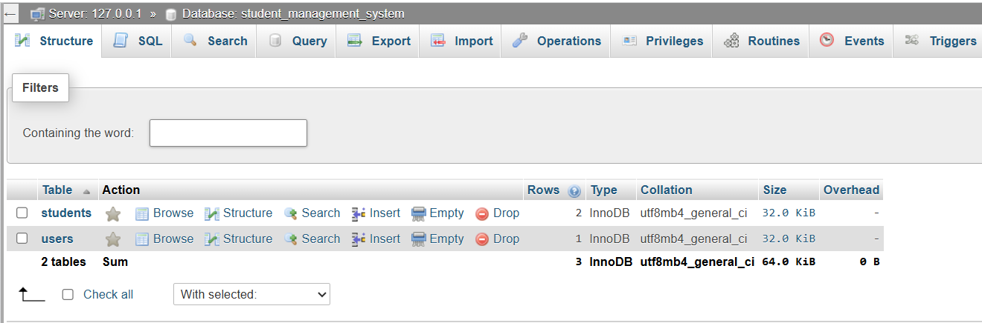
Figure 11 Empty student table

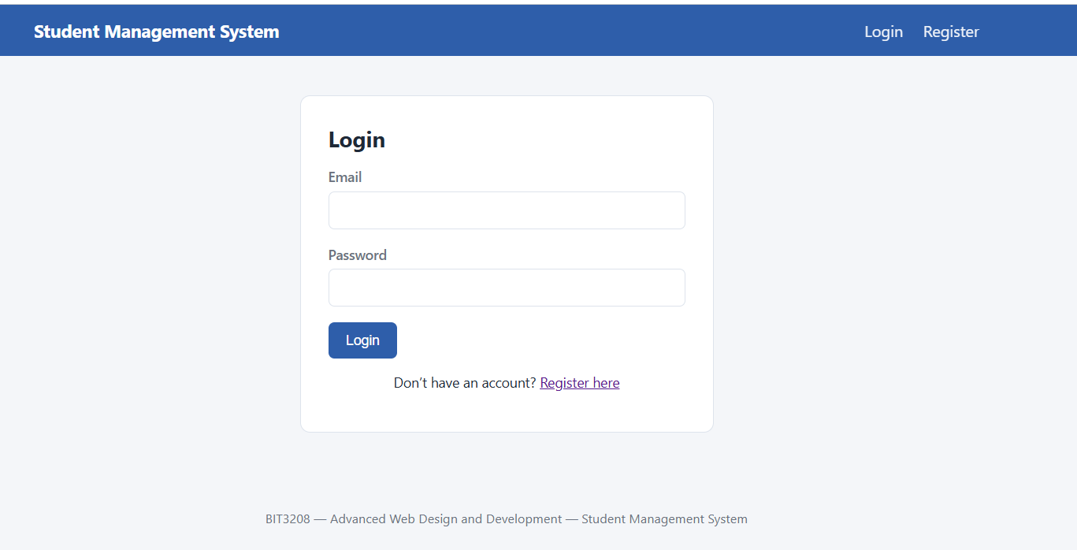
Figure 12 registration form

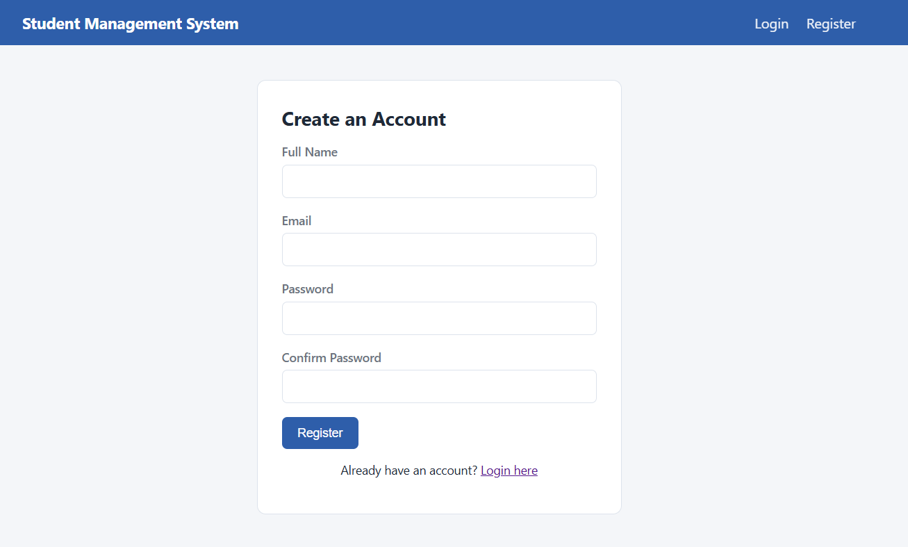
Figure 13 login form

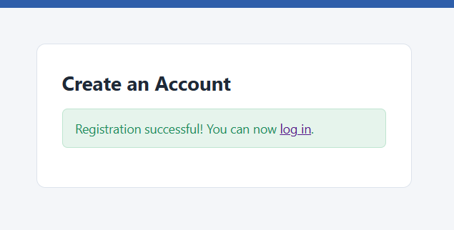
Figure 14 successful registration message

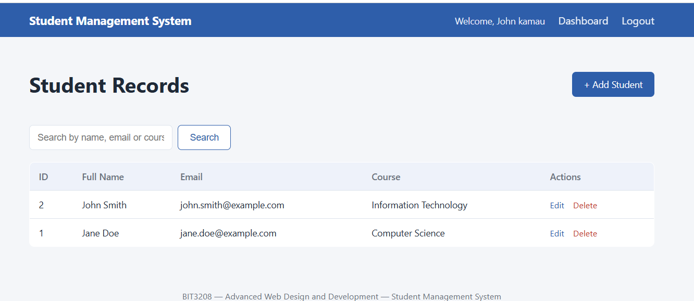
Figure 15 dashboard with the student lists

